|  |  |
| --- | --- |
| **CSE 420**  **Summer 2016**  **Surprise Quiz 02**  **10 Minutes**  **Set *A*** | Student Name:  Student ID:  Section: |

Construct the **LR (0) Automation** of following grammar.

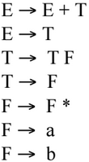

|  |  |
| --- | --- |
| **CSE 420**  **Summer 2016**  **Surprise Quiz 02**  **10 Minutes**  **Set *B*** | Student Name:  Student ID:  Section: |

Construct the **LR (0) Automation** of following grammar.

